2D SHAPES
OCR Tuesday 5 November 2019 – Morning (Calculator) Foundation Tier

OCR Tuesday 21 May 2019 – Morning (Calculator) Foundation Tier

OCR Thursday 8 November 2018 – Morning (Non-Calculator) Foundation Tier

OCR Thursday 7 June 2018 – Morning (Non Calculator) Foundation Tier
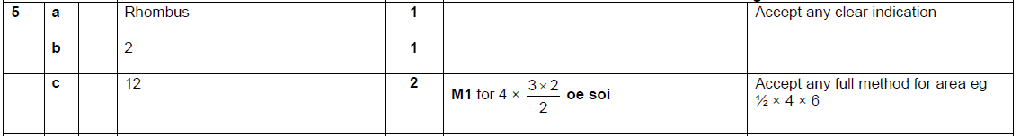

OCR Tuesday 12 June 2018– Morning (Calculator) Foundation Tier

OCR Thursday 2 November 2017– Morning (Calculator) Foundation Tier

AQA Tuesday 21 May 2019 – Morning (Non-Calculator) Foundation Tier

AQA Thursday 11 June 2019 – Morning (Calculator) Foundation Tier

AQA Tuesday 6 November 2018 – Morning (Non-Calculator) Foundation Tier

AQA Monday 6 November 2017 – Morning (Calculator) Foundation Tier

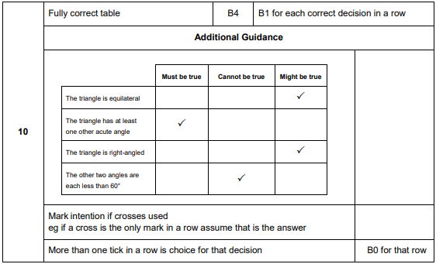

AQA Thursday 25 May 2017– Morning (Non-Calculator) Foundation Tier

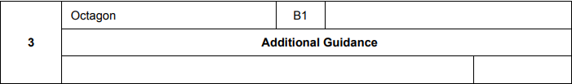
AQA Tuesday 13 June 2017 Morning– Morning (Calculator) Foundation Tier

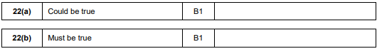
AQA Sample Paper 1– Morning (Non-Calculator) Foundation Tier

AQA Sample Paper 2– Morning (Calculator) Foundation Tier

